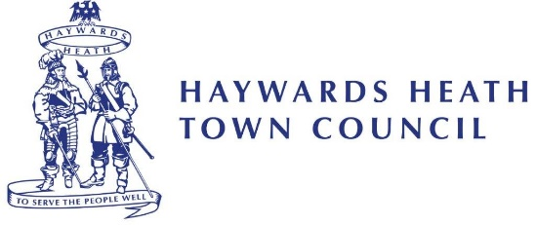

TOWN OF HAYWARDS HEATH

NOTICE OF ANNUAL TOWN MEETING

NOTICE is hereby given that the ANNUAL TOWN MEETING for the town of Haywards Heath will be held at the Town Hall, 40 Boltro Road, Haywards Heath, RH16 1BA on Monday, 29th April 2024.

The meeting is scheduled to start at 7.30pm.

AGENDA

1. Welcome from the Town Mayor, Cllr Stephanie Inglesfield.

2. Presentation by Mid Sussex Voluntary Action.

3. Haywards Heath Town Council Community Awards Presentations.

4. MINUTES
To notes the minutes of the Annual Town Meeting held on 15th March 2023.

5. Cllr Stephanie Inglesfield, Town Mayor will address the meeting.

6. Cllr Paul Lucraft, Leader of Haywards Heath Town Council will address the meeting

7. Public Question Time
To receive questions from members of the public.

The Town Mayor,

Cllr Stepahanie Inglesfield

Date of Signing: 8th April 2024

Note: This Notice has been issued by the Town Mayor as Chair of the Town Council in conformity with paragraph Local Government Act 1972 s9.

Town Mayor - Cllr Stephanie Inglesfield Town Clerk - Steven Trice

