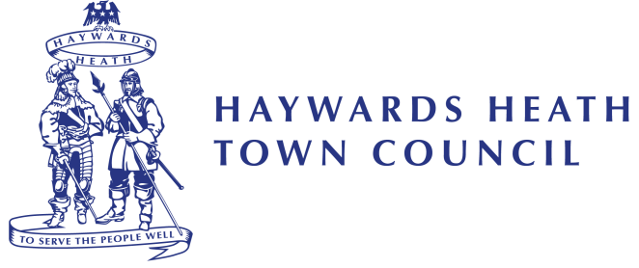

PRESS RELEASE: 09th April 2021

Haywards Heath Mayor pays tribute to HRH Prince Philip, The Duke of Edinburgh

“It is with great sorrow and grief that we heard of the passing of HRH Prince Philip, the Duke of Edinburgh. I am sure I speak for all of our community when I say that his loss will be felt by us all. The longest serving consort in our history, Prince Philip has been by the Queen’s side in friendship and support for over 70 years. What a true example of public service, duty and loyalty but most importantly, what a truly wonderful partnership. Our thoughts are very much with HM The Queen, and all of the Royal Family that we hold so dear in our hearts, and we send our deepest condolences to them at this time. Our Town Hall flag is flying at half mast as a mark of respect and sorrow at the loss of this great Royal consort and man.

HRH Prince Philip has inspired so many generations of our young people to achieve and succeed through the Duke of Edinburgh Scheme, something I know he was immensely proud of, but I wonder how many of our younger generation know that he was also an early advocate of the World Wildlife Fund, talking of the dangers to our wildlife and environment long before it became top news. He remained committed to his family, his campaigns and his charitable causes until his death.

I am sure we will learn much more about all Prince Philip’s life and charitable endeavours over the coming weeks as we take time to reflect on the loss to our Nation. I ask our community to heed the requests of the Royal Family and to make contributions to a charitable cause in place of leaving flowers as a mark of respect to Prince Philip. I already have a very deserving charity in mind that I will make a donation to in his honour. I also direct our residents to the online Book of Condolence which the Royal Family are asking us to use to send their condolences to HM The Queen. This is available at www.royal.uk

Sir you will be missed by us all, Rest In Peace HRH Prince Philip, The Duke of Edinburgh.”

Cllr Alastair McPherson
Town Mayor Haywards Heath

Ends.
Notes to Editor:

ATT: Photo of HRH Prince Philip, The Duke of Edinburgh

For more information, please contact

Maria Horne
Marketing Communications Officer
Haywards Heath Town Council
Tel: 01444 455694
Email: maria.horne@haywardsheath.gov.uk

